The Client-Server Model

It is about many clients using services from a centralized server.

The Client-Server model is about a client that interacts and makes requests to a computer server.

A client is the way that the person interacts with the server.

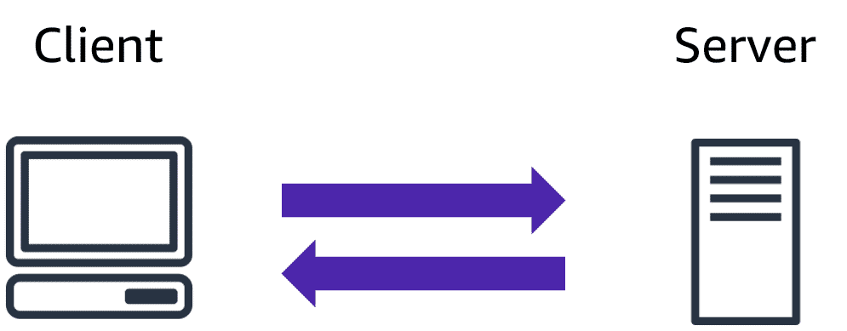

The server does tasks for the client and returns information.

What is Cloud Computing?

Cloud computing is a computing service made available over the internet.

Cloud computing is a pay-as-you-go model for delivering IT resources.

You pay only for what you use.

Deployment Models

There are three different kinds of deployment models:

* Cloud-based - Everything runs in the cloud.
* On-premises - On-Premises Deployment is also known as private cloud deployment.
* Hybrid - In a hybrid deployment, you connect cloud resources to an on-premises infrastructure.

The models are different ways of accessing compute services - over the internet, locally, or in a combination.

* Cost Savings ( if we don’t configure properly, then we get more bill )
* Faster Application Development and Release
* You do not have to invest in a data center, servers, and other resources.
* The cloud services are a variable expense.
* You can use the services from the start and consume more as you grow.
* Cloud computing is about shared resources.
* Sharing the infrastructure cost with hundreds of thousands of other customers lowers the overall costs.
* Cloud computing reduces operation and lets you focus on important things, such as your applications and customers.
* The flexibility of cloud computing makes it easier to develop and deploy applications.
* You can test and utilize resources as you want in minutes.
* This freedom allows you to experiment and invent more.
* It allows for instant resource access.

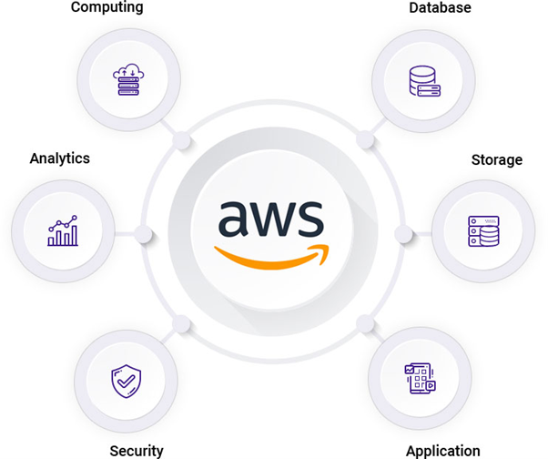

**Amazon Web Services** (AWS) is an on-demand cloud computing solution provided by Amazon, which includes 200+ services, platforms, and application programming interfaces that are leveraged by enterprises, governments, and individual customers on a pay-as-you-go model from data centers globally.

**DataCenter**

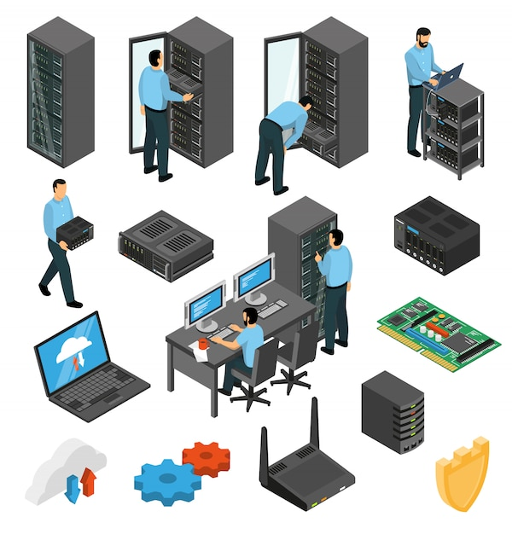 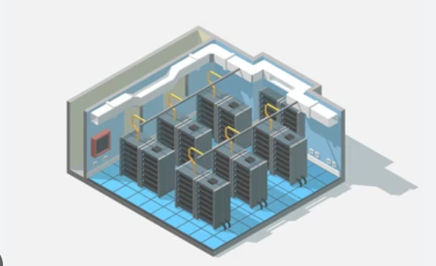

A **Data Center** is a computer room or a physical place where a large number of computer servers and their associated components including communication networks, storage devices, backups, environmental controls, and many others exits. As you know, the internet is based on a large group of networked server machines (from many datacenters) that are used by different organizations to process, store, and distribute large amounts of data.

Organizations need to provide quality of services by processing business transactions and instant data delivery to their clients, so it is the main reason why datacenters come to the existence. Data centers are improving the efficiency and scalability by adopting technologies including IoT (Internet of Things), Cloud computing and Virtualization applications.

Every data center is designed according to the needs and requirements of a particular organization in a well-constructed and safe building having the following components:

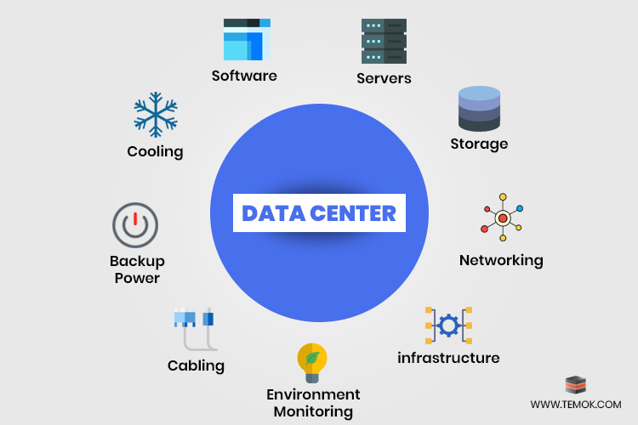

**Virtualization** can be defined as a process that enables the creation of a virtual version of a desktop, operating system, network resources, or server. Virtualization plays a key and dominant role in cloud computing.

In cloud computing, Virtualization facilitates the creation of virtual machines and ensures the smooth functioning of multiple operating systems. Virtualization and Cloud Computing work hand in hand to ensure that you will get advanced and sophisticated levels of computing.

Types of Virtualization:

1. Hardware Virtualization.
2. Operating system Virtualization.
3. Server Virtualization.
4. Storage Virtualization.

Types of Virtualizations software

There is a point where hardware becomes end of life and end of support, which basically means it is too outdated to perform efficiently. Despite hardware being more reliable with new technologies put in place and steps able to be taken to [extend their life](https://www.futurelogic.com.au/1-simple-solution-to-extend-the-life-of-your-pc/) (i.e. SSD Hard drives, memory upgrades), they will inevitably need to be replaced.

Every 4-5 years we need to replace the Hardware because spare parts won’t available

#### **Hardware Refresh?**

A hardware refresh is the process of replacing your entire network. A hardware refresh will safely and effectively replace all your technical equipment to improve your business. This can include all your **Datacenter** hardware, workstations, your firewalls, and even your server.

# **Regions, Availability Zones, and Local Zones**

Amazon cloud computing resources are hosted in multiple locations world-wide. These locations are composed of AWS Regions, Availability Zones, and Local Zones.

* **AWS Region** is a separate geographic area.
* Each AWS Region has multiple, isolated locations, single Datacenter or multiple Datacenters known as **Availability Zones**.
* **Local Zones** are a type of AWS infrastructure deployment that place compute, storage, database, and other select services closer to large population, industry, and IT centers, enabling you to deliver applications that require single-digit millisecond latency to end-users. A Local Zone is an extension of an AWS Region that is geographically close to your users

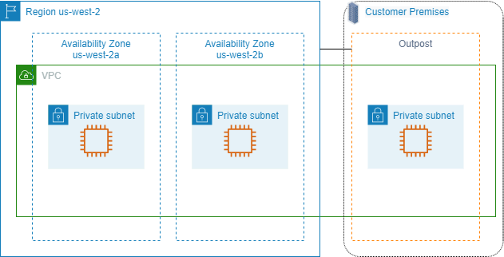 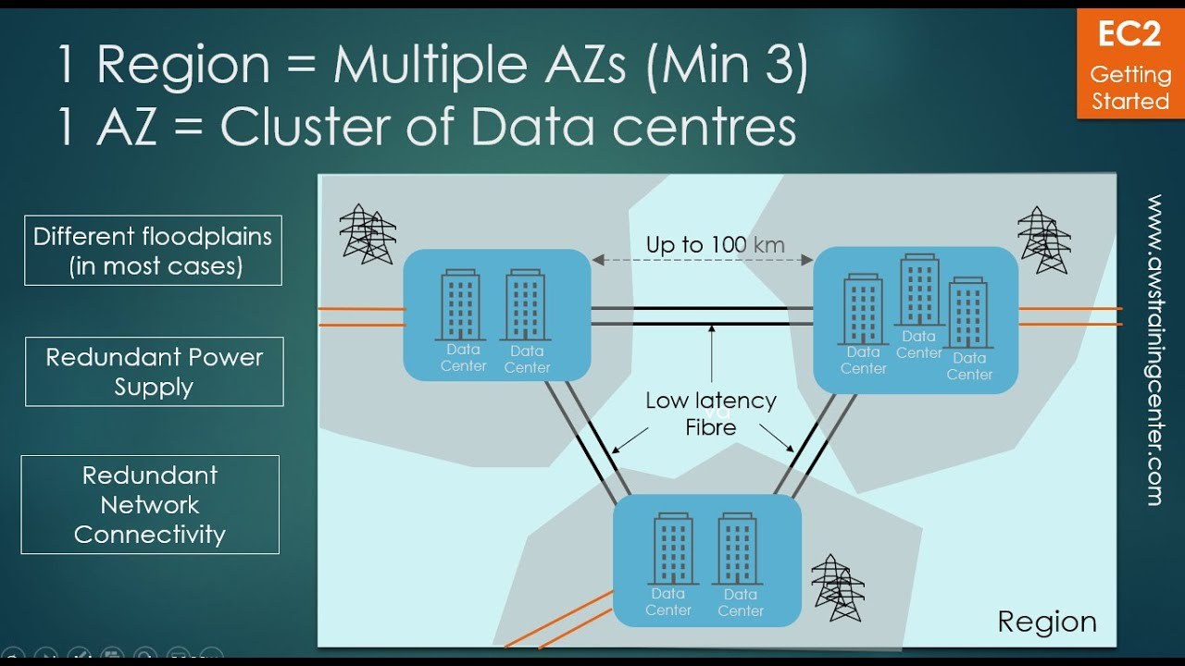

Every Availability zone is communicated with each other by default but in b/w Regions kavali ante we have configure in different ways.

No Company will deploy services through portal, They will use Automation tools like Terraform etc.

Edaina AZ lo mana application deploy chesinappudu adi down ayte mana application inkoka AZ lo automatic ga start avvadu. Endukante ala avali ante akkada kuda Hardware resources undali, so mana application failover ayyi automatic ga start ayyentavaraku hardware manakosam reserve cheyaleru, if chesina kuda manam danikosam cost pay cheyali dani badulu manam em chestam ante inkoka server ne akkada deploy chestam

So ee vidam ga manam mana application ni distributed ga deploy chestam, for **High availability** and mana deggara budget unte so complete region ni inko region lo deploy chestam and dani **Disaster Recovery** antam.

A **service-level agreement** is a commitment between a service provider and a customer. Particular aspects of the service – quality, availability, responsibilities – are agreed between the service provider and the service user.

Production systems yepudaina kuda multiple AZ lo distribute chesi pedtam

2 devices communicate kavali ante IP address undali

IP V4

IP V6 – currently applications are not support this one

**IP V4**

0.0.0.0 – 255.255.255.255 – any ipv4 address should be range in b/w these

* 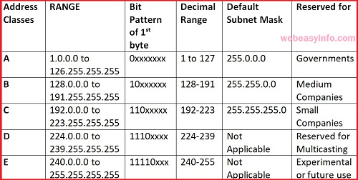We use only class A, B, C, Class D and E we don’t use
* World lo ye range IP’s ina kuda A,B,C lo matrame untai

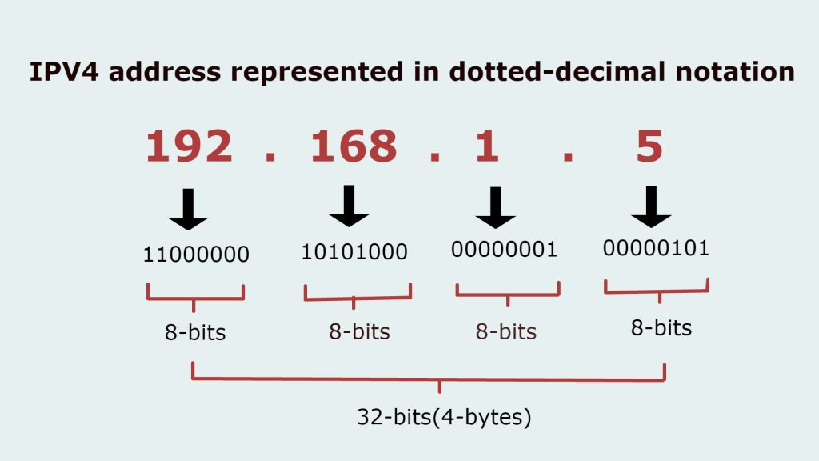

**IANA**, the Internet Assigned Numbers Authority, is an administrative function of the Internet that **keeps track of IP addresses, domain names, and protocol parameter identifiers that are used by Internet standards**.

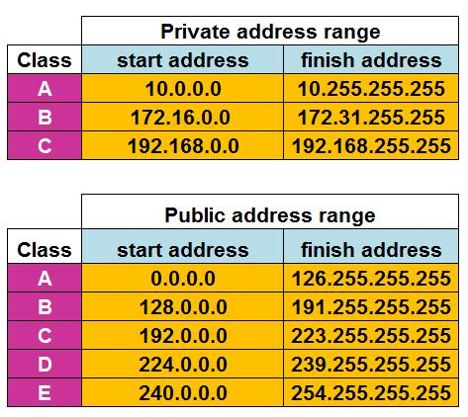

Private IP’s won’t go outside internet. They must be Unique

Office nundi traffic bayataki vellali ante through Public IP dwara matrame vellali

Internet service provider vallu internet line tho paatu oka Public IP kuda provide chestaru

**NAT** stands for network address translation. It’s a way to map multiple local private addresses to a public one before transferring the information.

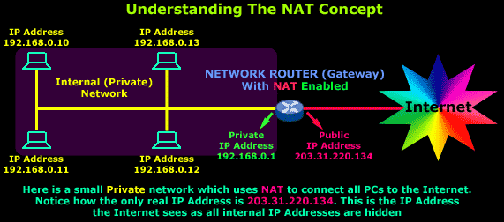 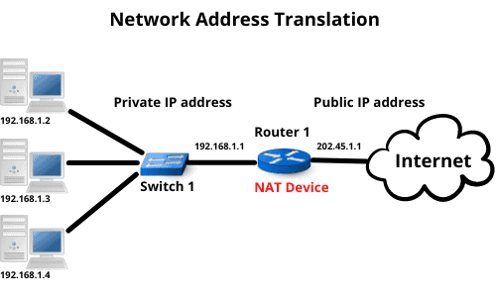

Subnetting of IP Address

Subnetting is a method of dividing a single physical network into logical sub-networks (subnets). A subnet's purpose is to divide a huge network into a collection of smaller, interconnected networks. Oka IP range lo Yenni ip’s vastai anedi subnet mask decide chestundi.

**10**.0-255.0-255.0-255

**255**.0.0.0 **/8** (255 unna chota paina em maradu) 255 is 8 bits

**10**.**0**.0-255.0-255

**255**.**255**.0.0 **/16**

**10**.**0**.**0**.0-255

**255**.**255**.**255**.0 **/24**

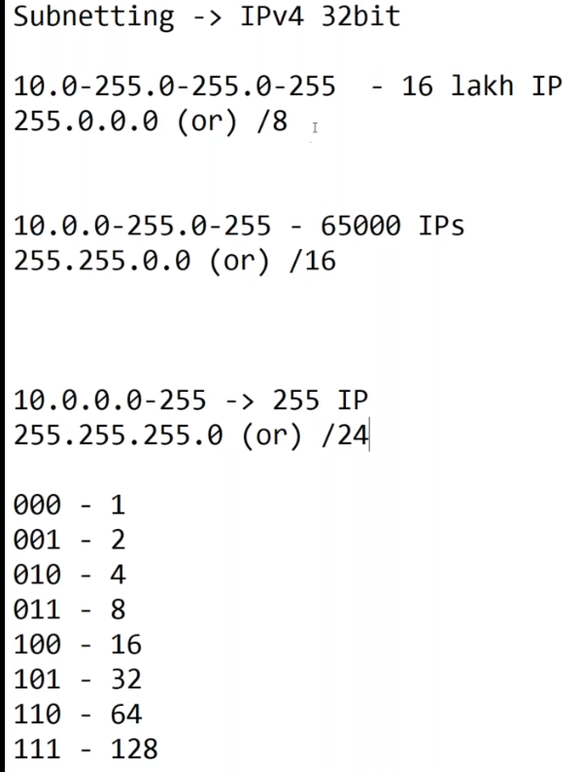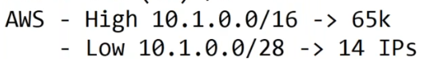--When we create VPC at time we create /16 big network once it is created can’t modified

--In this scenario as per the requirement if we provide the IP subnet in multiple subnets like this all IP will be wasted and this is not a Best Practice this is Worst practice

--This is the Best and Efficient way to do subnetting as we have fulfilled our requirement in a single subnet. Even though some IP are wasted it is acceptable. This can be achieved by using online subnet calculator.

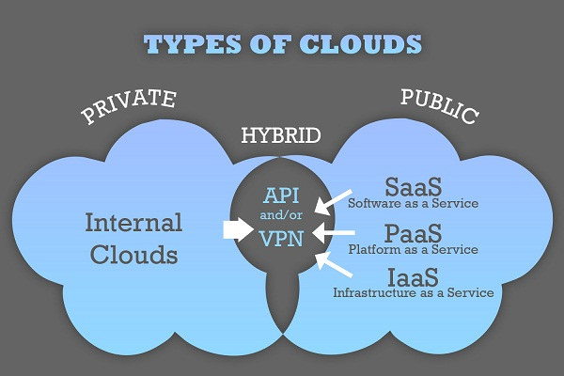

### **[cloudping.info](https://www.cloudping.info/)**

[https://www.cloudping.info](https://www.cloudping.info/)

A website for measuring network latency from your browser to various cloud provider datacenters around the world.